Assignment 23.1

Problem Statement Create a database named 'custom'. Create a table named temperature_data inside custom having below fields:

1. date (mm-ddyyyy) format

2. zip code

3. temperature

The table will be loaded from comma-delimited file.

Load the dataset.txt (which is ',' delimited) in the table.

According to the question first I created custom database so that I can use custom database.

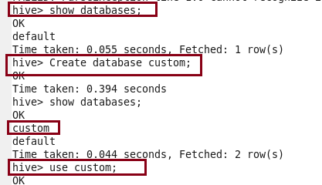



After that I am creating a table named temperature_data and then

loading the given dataset into table.

Then, to display the table I am using select command .

